Inspiration for Tomorrow Inc
is
proud to present

F.E.N.C.E.

FREEDOM. EXPRESSION. NONJUDGMENTAL. COURAGE. ENTHUSIASTIC

October is Domestic Violence Awareness Month.
We are inviting you to come out and show your support for victims and survivors of Intimate Partner Violence.

**Guest Speakers**
** Food & Light Beverages will be served**

DATE: Saturday October 20, 2018
TIME: 1 pm to 4:00 pm
LOCATION: Fountain of Grace
427 Turnpike St Canton, MA 02021
CONTACT: 508-474-9804
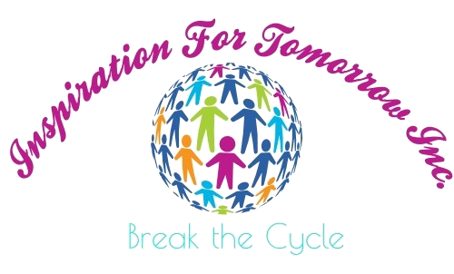
FREE ADMISSION

TO GET YOUR TICKET NOW GO TO EVENTBRITE.COM

