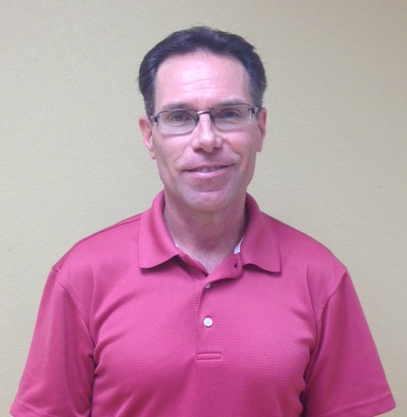
“Love Is Stronger Than Hate”
Was the message a grieving dad gave to 1,000 people at his daughter’s funeral after she was brutally murdered in a DV incident. The Love > Hate Project was created from that message.¹

“A Message From Jessie is real and graphic, a moving Call to Action.”²

“Dr. Buck is a dynamic speaker with a powerful message. Since Jessie’s passing, he works tirelessly to educate, motivate and inspire minds and hearts to add Love to our world and to end violence.”²

This will be a courageous presentation full of hope and insight.²

People are challenged to examine underlying belief systems and attitudes that result in intimate partner violence, and work to create change in them.
Stop The Silence:
End Domestic Violence

Featured Speaker:
Dr. Buck Blodgett
Executive Director
The LOVE > Hate Project

October 25th, 2018
7pm

Elgin Community College
Seigle Auditorium
Building E
University and Business Center
1700 Spartan Drive
Elgin, IL 60123

1.5 Free CEU’s for
LPC/LCPC, LSW/LCSW,
CDVP & CPAIP

Directions once on the Elgin Community College campus:
Park in parking lot E and enter into building E

For more information please contact:
Community Crisis Center
847-697-2380

