Family Forum
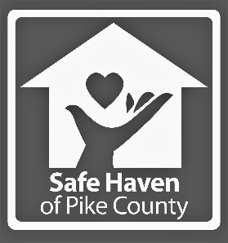
Dingmans Ferry United Methodist Church
115 Myck Road
Dingmans Ferry, PA 18328
Monday, October 15th
5:45 pm

1 in 3 girls and 1 in 5 boys will be sexually abused before they reach 18 years old.
Safe Haven of Pike County offers free services to abuse victims and their families.
We are offering a FREE open forum & discussion for parents about recognizing signs of child abuse and responding to suspected abuse. This is a great opportunity for concerned parents and caregivers to connect with other like-minded community members, discuss concerns, and learn helpful prevention skills. Attendees will also have the chance to learn about the different abuse & bullying prevention programs that Safe Haven can offer (free of charge) to schools, daycares, youth associations, and other youth organizations.

Pizza & childcare with crafts and games will be provided.

Recognizing & Responding
to Signs of Child Abuse
Safe Haven of Pike County
570-296-2927
402 Broad St. Milford, PA 18337
Follow us on Facebook for updates & events
@safehavenofpike

