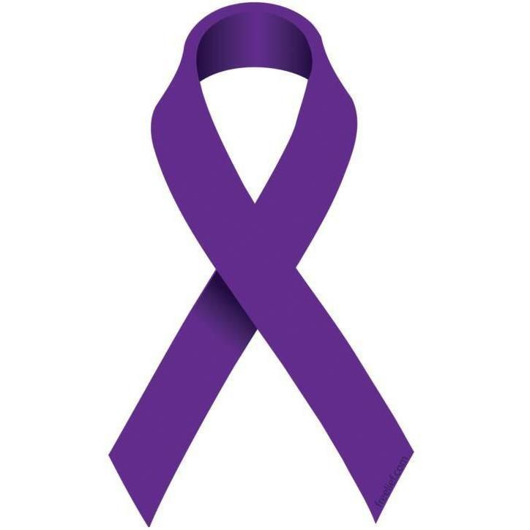
In recognition of
Domestic Violence Prevention Month
OCTOBER 2020
Angel Wings Outreach Center
Third Annual Rainbow Tea
“What Happens Next?”
Monday, October 26, 2020, 10:00 AM – 12:00 PM

Special guest speakers include members of the Mississippi Attorney General Office, Lark Johnson and Amanda Jasper along with domestic violence survivor Sylvanna Booth.

AND IN NOVEMBER

Angel Wings Outreach Center
In partnership with
Zeta Phi Beta Sorority, Inc., Rho Iota Zeta Chapter
Mental Health and Domestic Violence
Melissa Green, MSW, guest speaker
Friday, November 13, 2020, 10:00 a.m. – 11:00 a.m.

To register email AWOC at angelwingsoutreachcenter@gmail.com. Please provide your name and mailing address and indicate if you plan to attend either or both events. For tea participants only, once registration is complete you will receive a packet including a program outlining the event, a tea bag and a happy!

